Standard Operating Procedure:
Dimethyl Zinc and Pyrophoric Materials

According to the Safety Data Sheet (SDS) for dimethyl zinc special precautions must be taken when working with this chemical. Below are some of the characteristics of dimethyl zinc followed by handling and storage requirements necessary to use the chemical in the laboratory. Include this information in the laboratory Chemical Hygiene Plan.

Chemical Classifications:
CAS: | 544-97-8 | 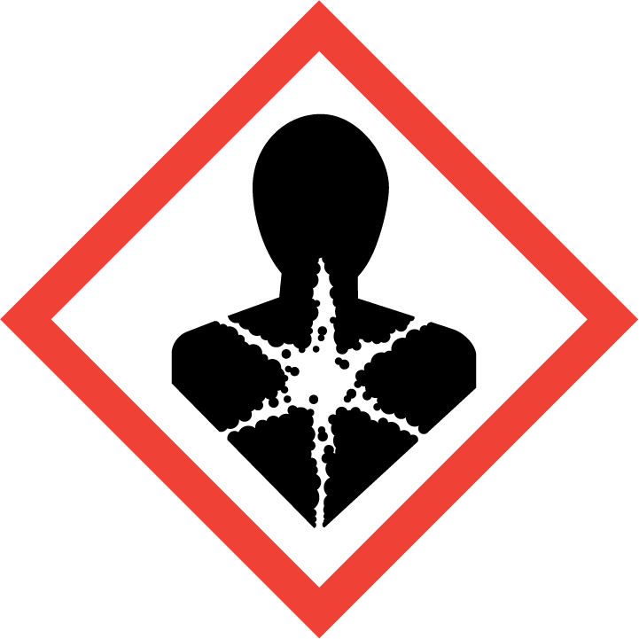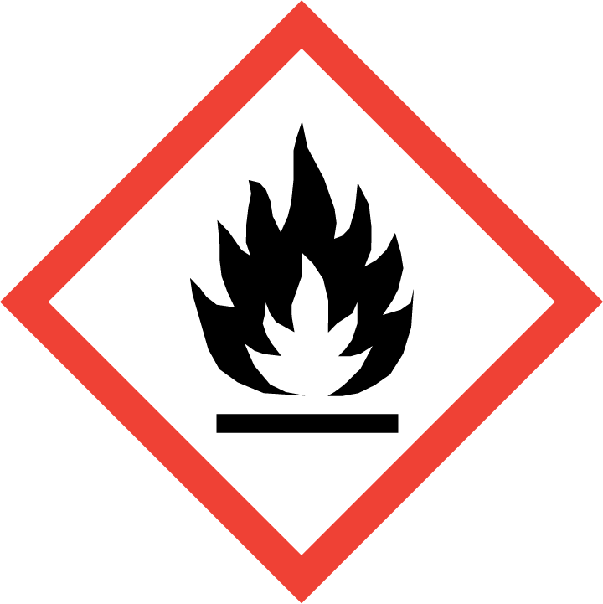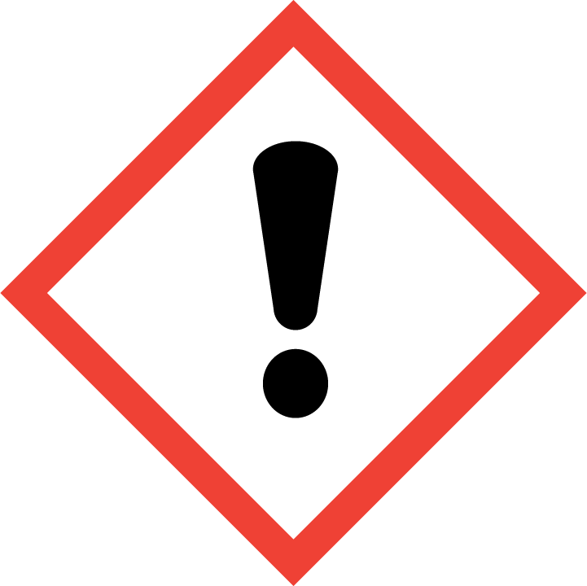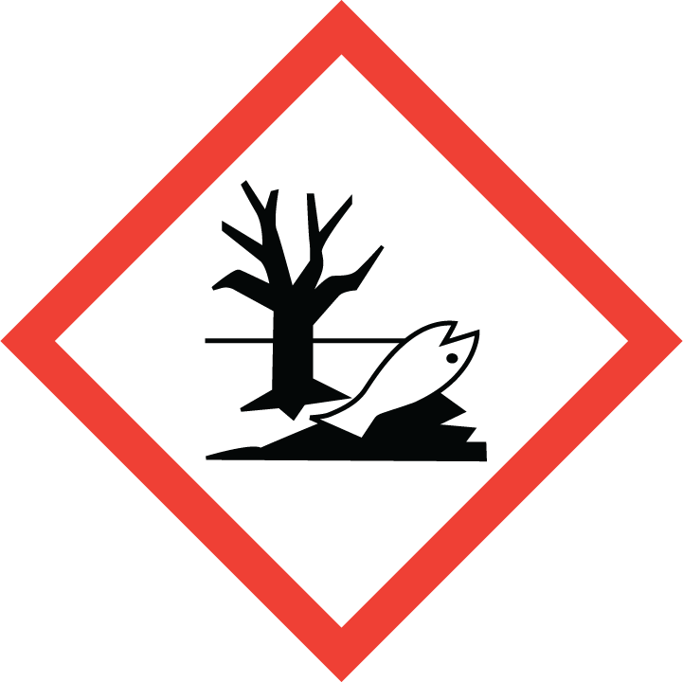
Class: | Flammable, Pyrophoric, Target organ toxicity, Corrosive, Teratogen, Reproductive hazard, Aquatic toxicity
Molecular Formula: | C2H6Zn
Form (physical state): | Liquid
Color: | N/A
Boiling Point: | 46 ºC

Brief Safety Overview:
- Hazard Classification:
  - Catches fire spontaneously if exposed to air.
  - In contact with water releases flammable gases that may react spontaneously.
  - Self-heating in large quantities; may catch fire.
  - Corrosive; causes severe skin burns and eye damage.
- The Principal Investigator is responsible for training employees using the material. The training should include a discussion of the known and potential hazards and an explanation of the relevant policies, techniques and procedures including the proper use of personal protective equipment and containment equipment (engineering controls). Employees should be trained initially and then annually thereafter. Their knowledge, competence and practices should be evaluated and documented. Sigma Aldrich Technical Bulletins AL-134 and AL-164 are appropriate reference materials.
- Limit access to authorized users.
- Transportation of the chemical within the facility should be performed using a sealed, non-breakable secondary container.
- In case of fire use Class C extinguishing powder. Do not use water. Individuals must be trained to use extinguishing equipment prior to use.

Minimum Protective Clothing:
- FR (flame resistant) lab coat
- Safety glasses (ANSI approved) or chemical splash goggles
- Two pair 4 mil nitrile gloves (single-use disposable for dexterity) or butyl rubber
- Face Shield (optional)
- Nomex/Leather gloves (optional)

Minimum Protective Equipment:
- Properly functioning Fumehood or glovebox required.
- Access to a fire extinguisher (Class C)
- Portable lexan safety shield (optional)
- Double needle or cannula (optional depending on volume handled)

Handling Instructions
Training and Work Practices
- Principle investigator must authorize trained individuals to work with reactive chemicals. Sigma Aldrich Technical Bulletins AL-134 and AL-164 are appropriate reference materials for review, but do not replace the need for hands-on training and experience.
- Training must include observation with direct supervision with specialized equipment. This training and review of this SOP should be documented.
- Training must include a review of emergency response procedures including how to respond to a fire (R.A.C.E.), how to use a fire extinguisher (P.A.S.S.), emergency evacuation routes, location of fire alarm pull stations, and point of refuge outside of building exit.
- Researchers are prohibited from working alone. A co-worker must be present in the lab during liquid transfer.
- Work in the Fumehood or glovebox at all times with sash as low as possible. Remove all unnecessary chemical containers, wash bottles and combustibles before starting work.

Storage
- Store material in an inert gas filled desiccator or glove box.
- Maintain in a location that minimizes exposure to intense light, heat of vibration.
- Do not store near oxidizing agents, alcohols or water.

Waste disposal:
- Store in desiccator under inert gas until Research Safety staff arrive for pickup.
- Contact Office of Research Safety by emailing labsafety@uthsc.edu for pickup.

Emergency Procedures
Spills or fires
- Spills or releases of small amounts of pyrophoric material may self-extinguish in the container of on the fume hood bench top. If this happens, secure all reaction containers and stop work. Report all fires to Research Safety and the Principle Investigator. Consult with the Principle Investigator to identify causes and solutions.
- Larger spills and/or fires must be treated as an emergency. If possible clost the fume hood sash, step away from the fume hood and send a co-worker to pull the fire alarm. Only fight a fire if the fire alarm has been activated, you have been trained in hands-on fire extinguisher use and your exit path is clear. Skin: Remove all contaminated clothing immediately. Wash with water and soap. Rinse thoroughly.
- Call Safety Affairs @ 8-6114 (if there is no answer, call UT Police @ 8-4444.) (Provide your name, phone number, location, and amount of material spilled)

Exposure Response
- Skin: Remove all contaminated clothing immediately. Wash with water and soap. Rinse thoroughly.
- Eyes: Rinse under water for 15 minutes then seek medical treatment.
- Inhalation: Move to fresh air.
- Ingestion: Seek medical treatment.

Technical Notes:
- Transfers of small volumes (1-25 ml) can be performed with glass Luer-lock syringe using dry nitrogen/argon and mineral oil bubbler. Never use plastic syringes for handling pyrophorics. –
- Transfers of larger volumes (>50ml) must be performed using a cannula with a Schlenk line or similar nitrogen/argon purged apparatus with mineral oil bubbler.
- Check the SDS for each pyrophoric to find compatible cooling solvents. In a spill/release acetone and 2-propanol will react violently with certain pyrophoric liquids (i.e. organolithiums). Consider hexane or heptane as alternatives.
- Ensure all systems, glassware, reaction/transfer/sample containers are dried and cooled to room temperature before use. –
- Dry and pure Nitrogen or Argon should have no more than 5ppm moisture or oxygen content.
- Argon must be used where lithium metal is a reactant to prevent the formation of lithium nitride.
- Pyrophoricity will vary between chemicals and also based on concentration, age and environmental conditions. Evaporation of carrier solvent can concentrate pyrophoric solutions and increase the hazard. Always titrate your pyrophoric to determine the concentration before use.
- Reactions with pyrophoric liquids are exothermic, always use larger than normal reaction vessels and provide pressure release on inert systems.

