Standard Operating Procedure:
(Name of compound or hazardous agent)

According to the Safety Data Sheet (SDS) special precautions must be taken when working with this chemical. Below is a description of the hazards followed by handling and storage requirements necessary to work with this material. Include this information in the laboratory Chemical Hygiene Plan.

Chemical Classifications:
CAS Number: | (Enter CAS Number) | 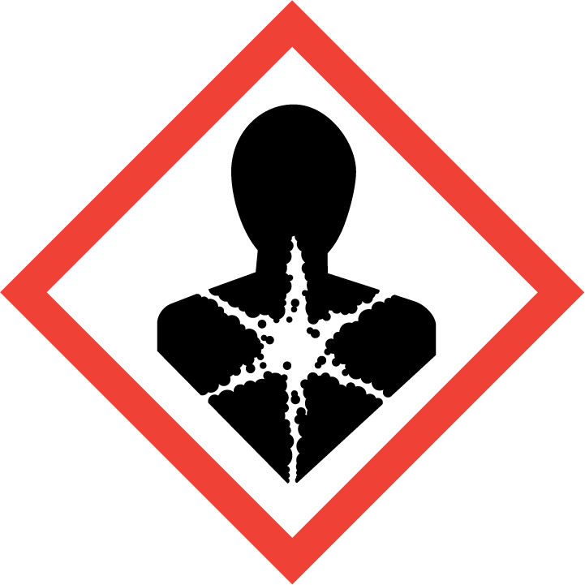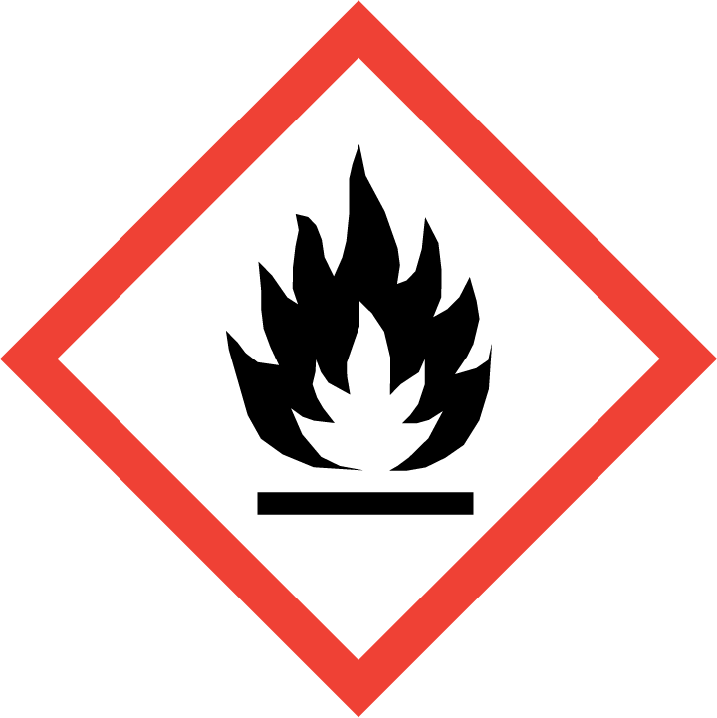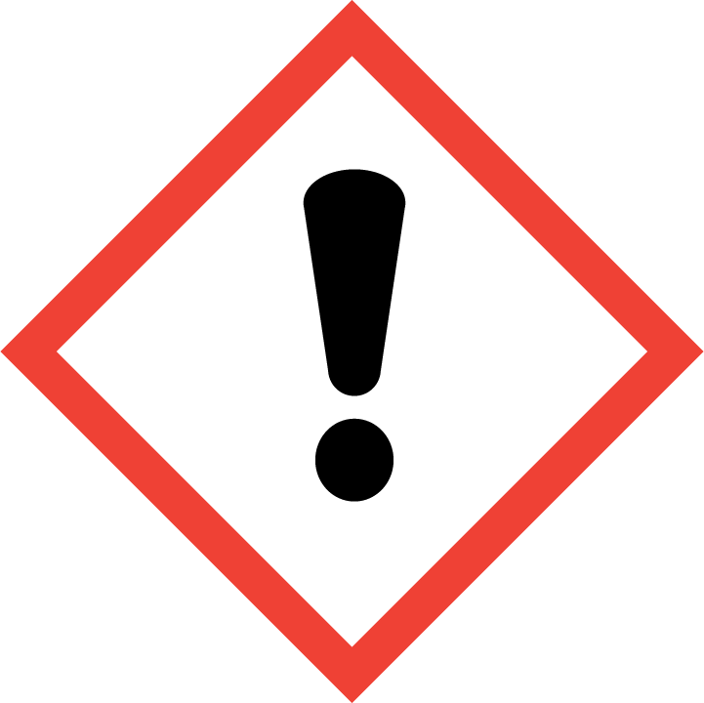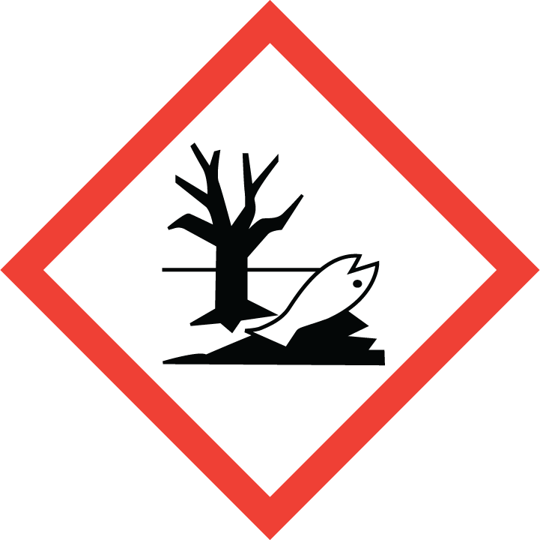  (Delete GHS pictograms for hazards that don’t apply)
Hazards: | (List hazards from safety data sheet. E.g. flammable, irritant, acute system toxicity, etc.)
Molecular Formula: | (Enter molecular formula)
Form (physical state): | (Enter physical state – solid, liquid, gas, aqueous)
Color and Physical Appearance: | (Enter color and physical appearance)

Brief Safety Overview:
- Hazard Classification:
  - (Describe hazards or hazardous conditions associated with this material or its handling.)
- The Principal Investigator is responsible for training employees using the material. The training should include a discussion of the known and potential hazards and an explanation of the relevant policies, techniques and procedures including the proper use of personal protective equipment and containment equipment (engineering controls). Employees should be trained initially and then annually thereafter. Their knowledge, competence and practices should be evaluated and documented.
- Limit access to authorized users. (If applicable)
- Transportation of the chemical within the facility should be performed using a sealed, non-breakable secondary container. (Transportation precautions if applicable)
- In case of fire use Class (Enter fire extinguisher class info from SDS) fire extinguisher. Individuals must be trained to use extinguishing equipment prior to use.
- (List or describe incompatible materials)

(continued)
Minimum Protective Clothing:
- (List required personal protective equipment. Described in Section 8 of the SDS. Contact the Office of Research Safety for assistance assigning appropriate PPE if necessary.)
- (Specify type of gloves if necessary)

Minimum Protective Equipment:
- (Specify required engineering controls such as chemical fume hood, shielding, etc. Described in Section 8 of the SDS)

Handling Instructions
Training and Work Practices
- (Describe handling instructions. List step by step procedure describing the required protective equipment, engineering controls and work practices for each step)

Storage
- (Describe storage requirements. Located in the Section 7 of the SDS)

Waste disposal:
- (Describe any specific handling or storage instructions for waste material)
- Label using the Hazardous Waste label accessible on the Office of Research Safety website.
- Contact Office of Research Safety by emailing labsafety@uthsc.edu for pickup.

Emergency Procedures
Spills or fires
- (Describe spill clean-up procedure. Located in Section 6 of the SDS.)
- Fires and large chemical spills must be treated as an emergency. Notify your co-workers and supervisor and be prepared to evacuate the area. Once in a safety location contact the Research Safety Affairs at 8-6114 or call the UTHSC Police at 8-4444. In the event of fire if possible close the fume hood sash, and send a co-worker to pull the fire alarm. Only fight a fire if the fire alarm has been activated, you have been trained in hands-on fire extinguisher use and your exit path is clear. Skin: Remove all contaminated clothing immediately. Wash with water and soap. Rinse thoroughly.
- Call Safety Affairs @ 8-6114 (if there is no answer, call UT Police @ 8-4444.) (Provide your name, phone number, location, and amount of material spilled)

Exposure Response
- (Described in Section 4 of the SDS. The most common response actions are described below.)
- Skin: Remove all contaminated clothing immediately. Wash with water and soap. Rinse thoroughly.
- Eyes: Rinse under water for 15 minutes then seek medical treatment.
- Inhalation: Move to fresh air.
- Ingestion: Seek medical treatment.

Technical Notes:
- (Describe any additional precautions of technical issues that should be brought to the attention of the individuals handling the material.)

